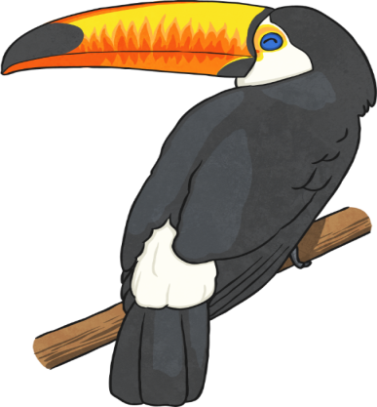

**Mathematical Links**

Measure out animals of the Rainforest on the playground. Compare sizes.

**Geography Links**

Name the seven continents of the World.

Locate the seven continents of the World.

Name and locate the five oceans..

Map and atlas skills.

Understand geographical similarities and differences through studying the human and physical geography of a small area of the United Kingdom, and of a small area in a contrasting non-European country.

Identify seasonal and daily weather patterns in the United Kingdom and the location of hot and cold areas of the world in relation to the Equator and the North and South Poles.

Use world maps, atlases and globes to identify the United Kingdom and its countries, as well as the countries, continents and oceans.

**Religious Education**

L1.7:WhoisJewishandhow do they live? [God/Torah/people]

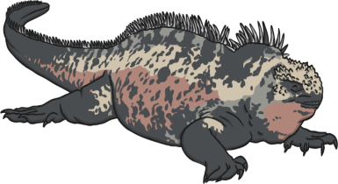

**D and T/Art**

3D -Amazon Rainforest in a box.

Use different medias to create layers of the rainforest.

Use pencil, crayon and paint to draw rainforest animals.

**Famous Artist- Henri Rousseau – William Morris**

**Rainforests**

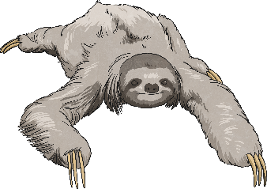

**Music –**

Find steady beats and perform using voices and tuned/untuned percussion instruments. Explore the theme of number and travel.

**Science**

Identify and name deciduous and evergreen trees

Explore and compare living, dead, and things that have never been alive.

Identify that most living things live in habitats to which they are suited and describehow different habitats provide for the basic needs of different kinds of animals and plants, and how they depend on each other. Identify and name a variety of plants and animals in their habitats, including microhabitats.

Describe how animals obtain their food from plants and other animals, using the ideaof a simple food chain, and identify and name different sources of food.

Offspring

**Literacy Links**

**Writing Opportunities**

Non-chronological report - Layers of the Rainforest/Rainforest animals.

Description of a Rainforest

**Reading List**

Rain Forest Wildlife -Jinny Johnson.

Living in the Amazon Rainforest - Anita Ganeri.

Slowly SlowlySlowly Said the Sloth-Eric Carle.

The United States of America- Millie Miller and Cyndi Nelson.

Rainforest - Elinor Greenwood.



Physical Education

Football

Athletics

Games

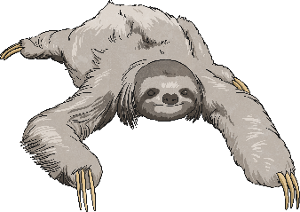

**Forest School**

Making habitats

Finding Microhabitats

Building Bug Hotel

Making mud/stick hedgehogs

**Computing**

|  |  |
| --- | --- |
| **PROGRAMMING A**    **Moving a robot (Y1)** | **DATA & INFORMATION**    **Grouping data  (Y1)**  **Online Safety** |