|  |  |  |
| --- | --- | --- |
| Geography – Rainforests | Year A Spring Term | Year 2/3 |

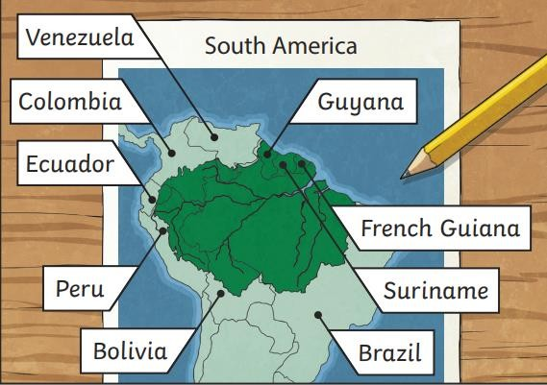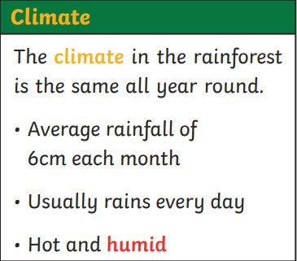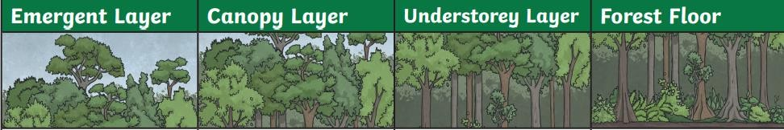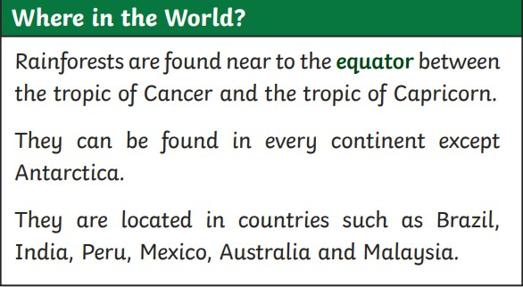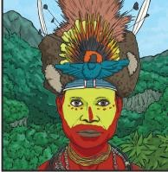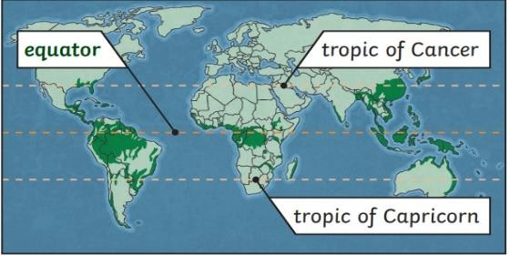

**At the end of the Unit I should be able to:**

* identify areas of the world that contain rainforests.
* use maps and atlases to locate rainforests
* describe the key aspects of a tropical climate
* describe the animals and plants living in the rainforest
* compare the Amazon rainforest to local woods
* explain the effects of humans are having on the rainforests.
* find the Tropic of Cancer and Capricorn on a map/globe
* explain why different animals live in different layers.

**Deforestation**

Trees are cut down:

* to create fields for farming cattle and growing crops.
* to produce timber and wood pulp to make furniture and paper
* to create space for housing.

**The Amazon Rainforest**

* 5.5millionsquarekm(previouslycovereda muchlargerarea)
* PartsinBrazil,Peru,Colombia,Venezuela, Ecuador, Bolivia, Guyana, Suriname and French Guiana
* 2milliontouristsperyear
* 170differentlanguagesspoken
* 250000nativetribescurrentlylivethere
* 2.5millioninsect species
* 40000+plantspecies•3000ediblefruits
* 2000+speciesofbirdsand mammals

**Vocabulary**

climate

Theaverageweather conditions over a long period of time.

deforestation The cutting down and clearing of forests.

equator

An imaginary line running around the widest part of the earth.

humid

Feeling very damp duetowatervapour in the air.

nativetribes

Theoriginalsettlers of an area.

species

A group of similar animalsorplants

weather

The specific condition on given day.

**Key Questions:**Where the rainforests in the World?

Are there seasons in the rainforests?

Are all the trees in a rainforest the same height as trees around our School?

Where do the animals live in a rainforest?

Why might the animals find it hard, to live in the rainforest in the future?