|  |  |  |  |
| --- | --- | --- | --- |
| Geography Focus | Pirates | Year 1 | Spring Term |

|  |  |
| --- | --- |
| Key People | |
| **Black Beard**  Blackbeard the Pirate: Myths, Truths and Legends | An English pirate who sailed around the West Indies and North America. He became a renowned pirate. He got his nickname because of his thick black beard |
| **Sir Francis Drake**  Sir Francis Drake | Biography, Accomplishments, & Facts | Britannica | An English sea captain, privateer and explorer. He carried out the second circumnavigation of the world in a single expedition. |
| **Anne Bonny**  Anne Bonny - Wikipedia | An Irish pirate who often disguised herself as a man and became one of the most recognisable wanted faces of the ‘Golden Age of Piracy’. |

|  |  |
| --- | --- |
| **Vocabulary** | **Definition** |
| **Pirate** | A pirate is a sailor who attacks other ships at sea and steals their property. |
| **Piracy** | Piracy is an act of attacking and robbing ships at sea. |
| **Cutlass** | A short sword with a slightly curved blade used by pirates. |
| **Booty** | Treasure (like money or jewels) stolen by pirates. |
| **Sloop** | A type of ship that moved very quickly and easily. It was perfect for chasing another ship to steal from them. |
| **Rigger** | A big and heavy ship. It carried lots of loot, up to 20 cannons and 200 men. |

|  |
| --- |
| Key Knowledge |
| **Continents**  There are seven continents in the World.  Asia  Africa  North America  South America  Europe  Australia |
| **Oceans**  There are five Oceans. They are:  The Atlantic Ocean  The Pacific Ocean  The Indian Ocean  The Arctic Ocean  The Southern Ocean |
| **The United Kingdom (UK)**  There are four countries in the UK. They are England, Ireland, Scotland and Wales. |
| **Where we live**  We live in England, a country in the UK. |

**Parts of a Pirate Ship**

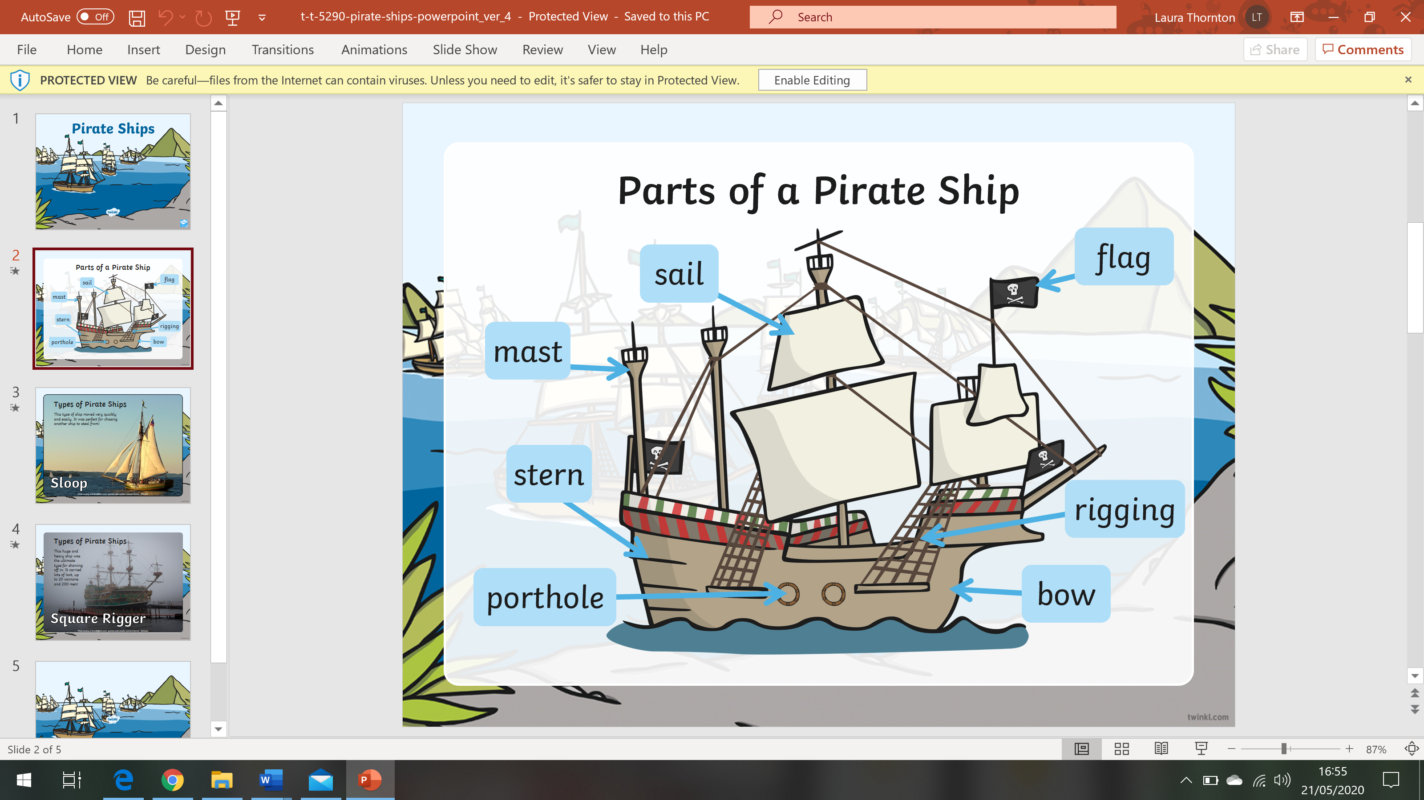

|  |  |  |  |  |  |  |  |
| --- | --- | --- | --- | --- | --- | --- | --- |
| **Timeline** | | | | | | | |
| **1557**  Conflict between England and Spain brought more pirates. | **1557 – 1580**  Sir Francis Drake circumnavigated the world. | **1588**  The Spanish Armada. | **1623 – 1638**  The Caribbean became a haven for pirates. Over 500 ships were raided and destroyed. | **1650**  The start of the ‘Golden Age of Pirates’. | **1718**  Blackbeard died in battle. | **1720**  Anne Bonny is captured along with 2 other pirates. | **1730**  The end of the ‘Golden Age of Pirates’. |

Hooks

* Pirate Day

