Transport Home Learning Activities

History  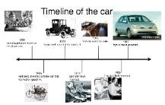  Find out about how your favourite vehicles have changed over time. Draw a timeline to show how a vehicle has changed from when it was first invented to now. |  |   Geography Take a journey through your local area and record the different types of transport you see. Draw a picture and label the different ways of travelling that you see. | 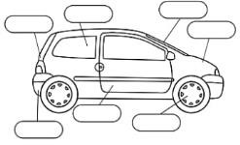  Art  Draw and paint a picture of your favourite transport and label the important parts, such as: headlights, tyres etc.
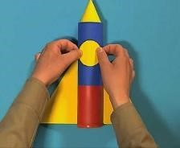  DT  Make a 3D model rocket or other transport of choice. Use the following video with your parent or carer to help you.  Mister Maker: How to Make a Mini Space  Rocket - YouTube | Computing  Remote Control  Toys  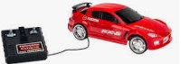  Make your toy go forward and go backward. Make your toy turn left and turn right. Explain how your toy will have to travel to go from the front door to the kitchen. Explain how your toy will have to travel to go from the TV to the front door. |  | PSHE  Make a “crossing the road safely” poster.  

