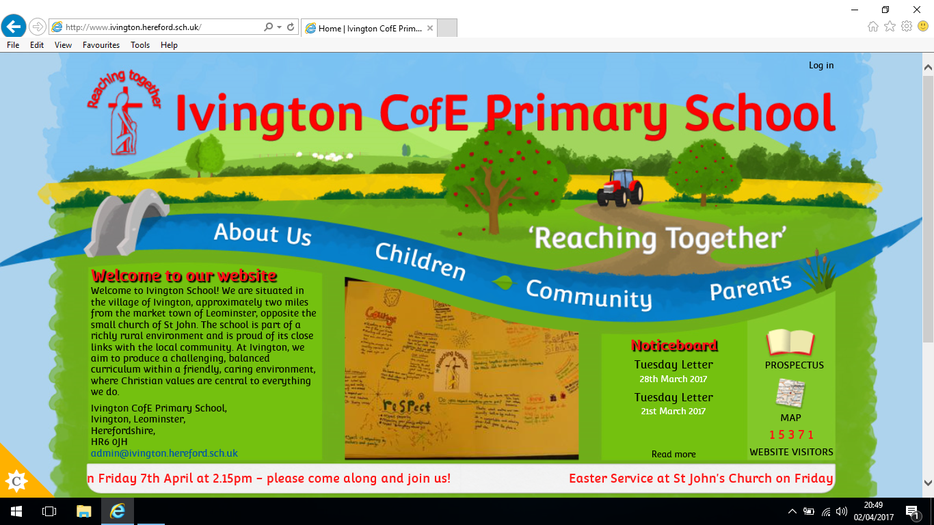

**Rule of Law**

* Consistent approach across school to follow behaviour. (behaviour Policy)
* Police/Fire station / Road safety / e-safety visits and talks.
* Bikeability (Year 6)

**Individual Responsibility and Liberty**

* Responsibility for own belongings
* Homework
* Reading bookmark challenge
* Educational Visits

**Democracy**

* Class rules
* Election of School Council
* Pupil Surveys
* Talent show auditions
* Year 5/6 roles and responsibilities
* Voting for Film Night
* Democratic votes for rewards
* Children’s voice in choosing the Values of the month

**Mutual Respect**

* Competitive Sports
* PSHE – Circle time / Class Assemblies
* RE Curriculum
* Paired class/school work
* Anti-Bully/ Being A Goof Friend Week
* Collective Worship Visitors – Paralympic Swimmers
* Community Singing at Local nursing homes
* Parents evenings/Open mornings
* Community helpers
* Church visits
* Adults model respectful behaviour
* School Behaviour Policy/ Reward Assemblies

British Value Overview

Ivington C of E Primary [](https://www.google.co.uk/url?sa=i&rct=j&q=&esrc=s&source=imgres&cd=&cad=rja&uact=8&ved=0ahUKEwjruqnvwIbTAhVDL8AKHUf-DwMQjRwIBw&url=https://en.wikipedia.org/wiki/Union_Jack&psig=AFQjCNEXE2cvsfCT4QyuYg8njqEVD1Iy7A&ust=1491247736450333)

**Tolerance of Faiths and Beliefs**

* RE Curriculum
* Whole School Communion
* Prayer Space
* Cultural Diversity Day
* Links with local churches- Harvest/Easter and Christmas Services
* Daily collective worship
* Open the Book
* Links with International School – Ambreni Tanzania

